D3 Interactivity– Data Visualization

# Exercise – D3

Student Name: Pulkit Agrawal Student Id: PXA180017

Date: 11-21-2018

Q1. PASTE A SCREENSHOT OF THE WHOLE OUTPUT SCREEN WITH TIMESTAMP.

Answer:

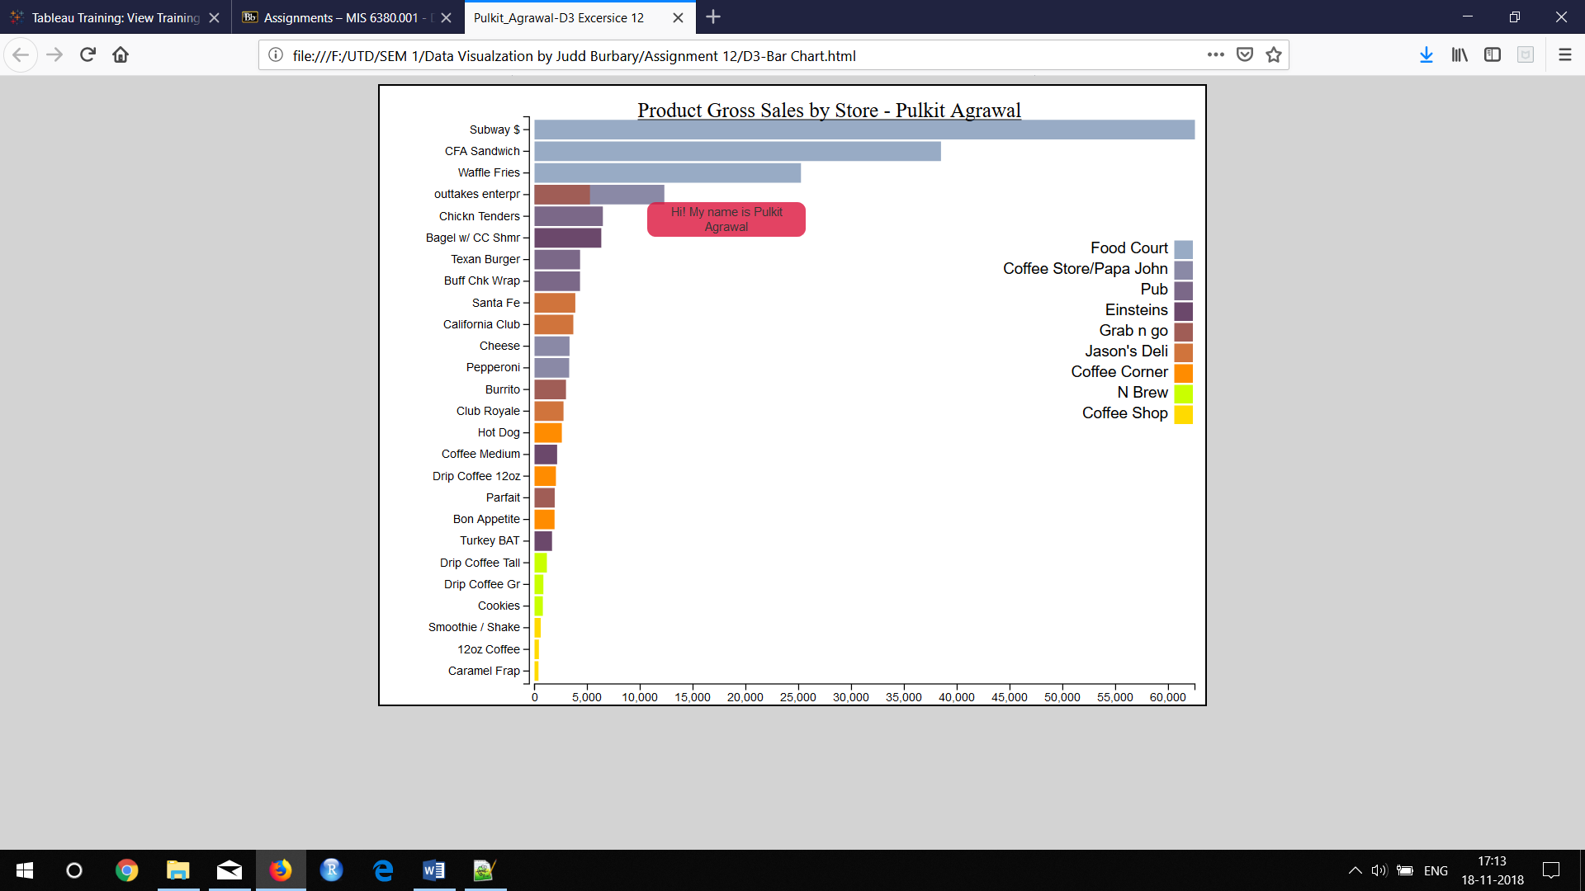

Q2. PASTE OF SCREENSHOT HOVERING OVER A BAR OF THE GRAPH DISPLAYING THE HIGHLIGHTING AND THE TOOLTIP.

Answer:

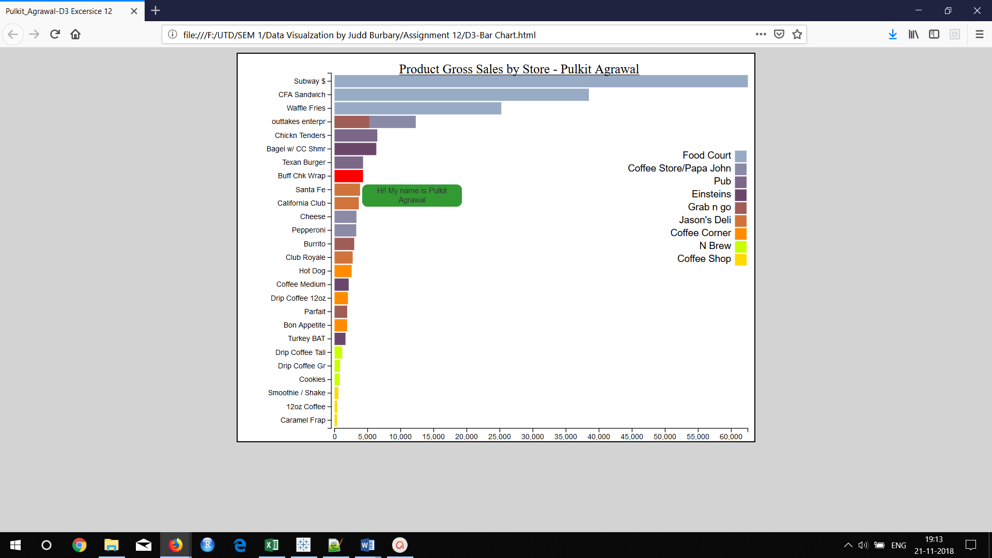

Q3. PASTE A SCREENSHOT OF THE TOOLTIP SHOWING THE AVERAGE PRICE

Answer:

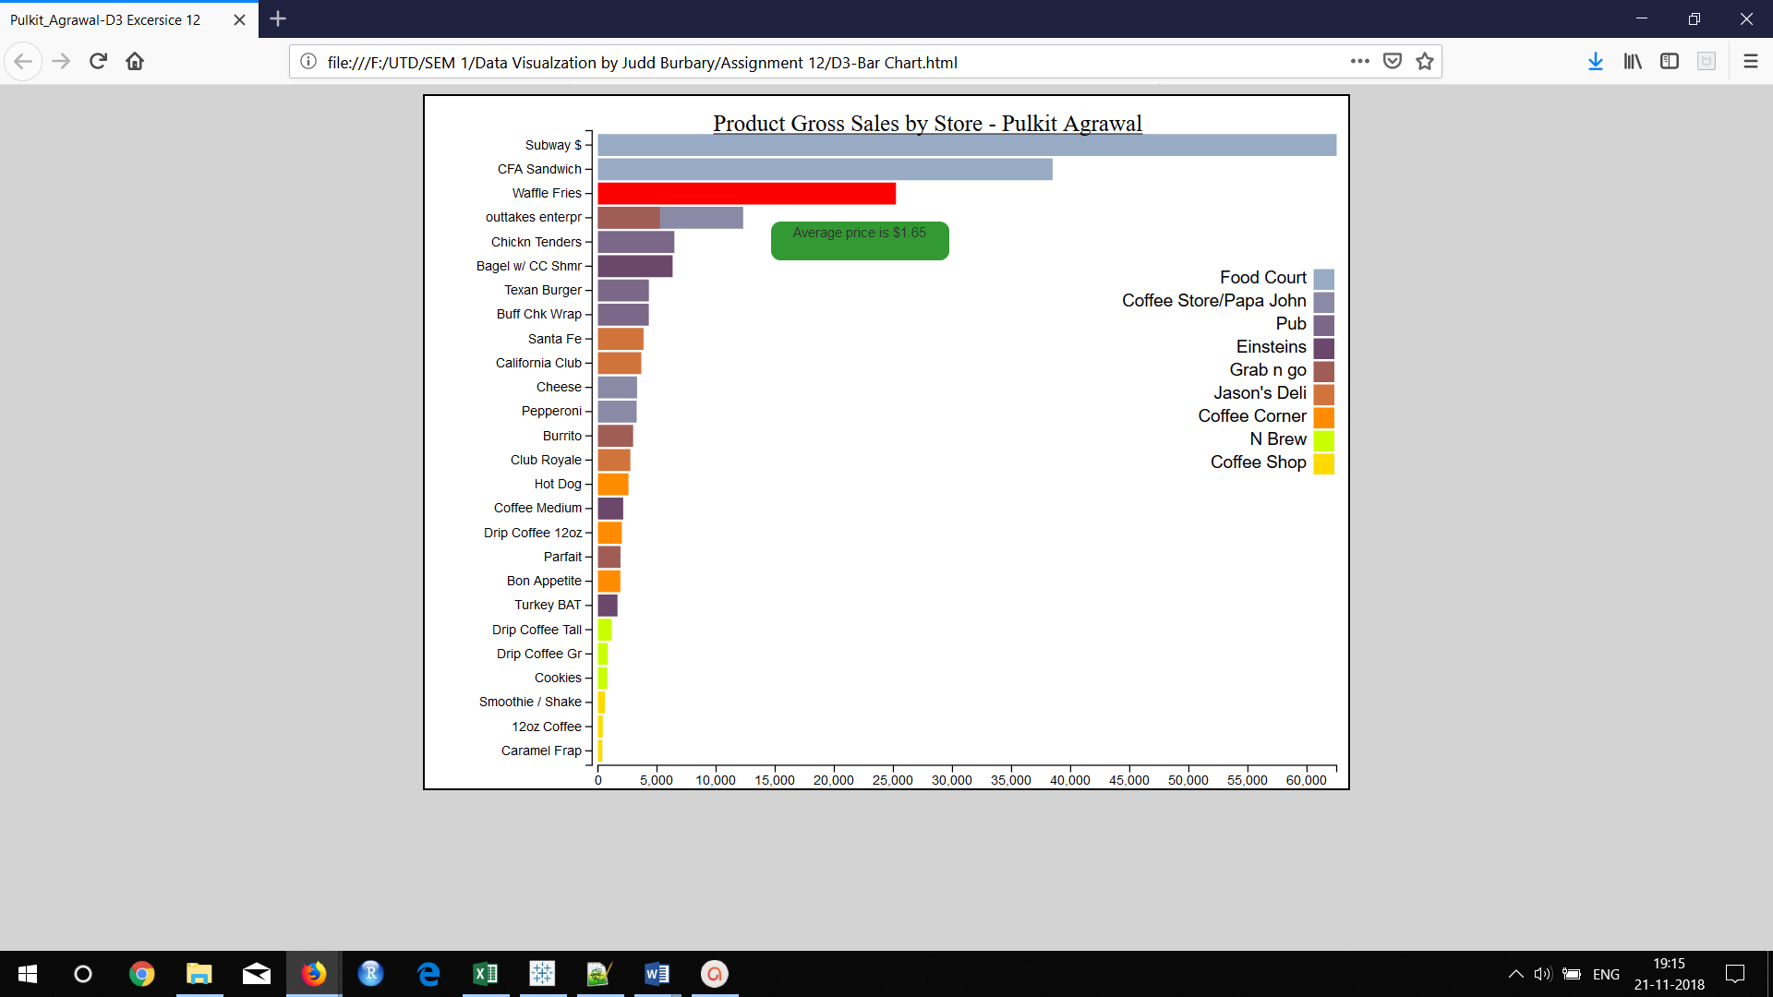

Q4. PASTE SCREENSHOT OF THE DROP-DOWN MENU

Answer:

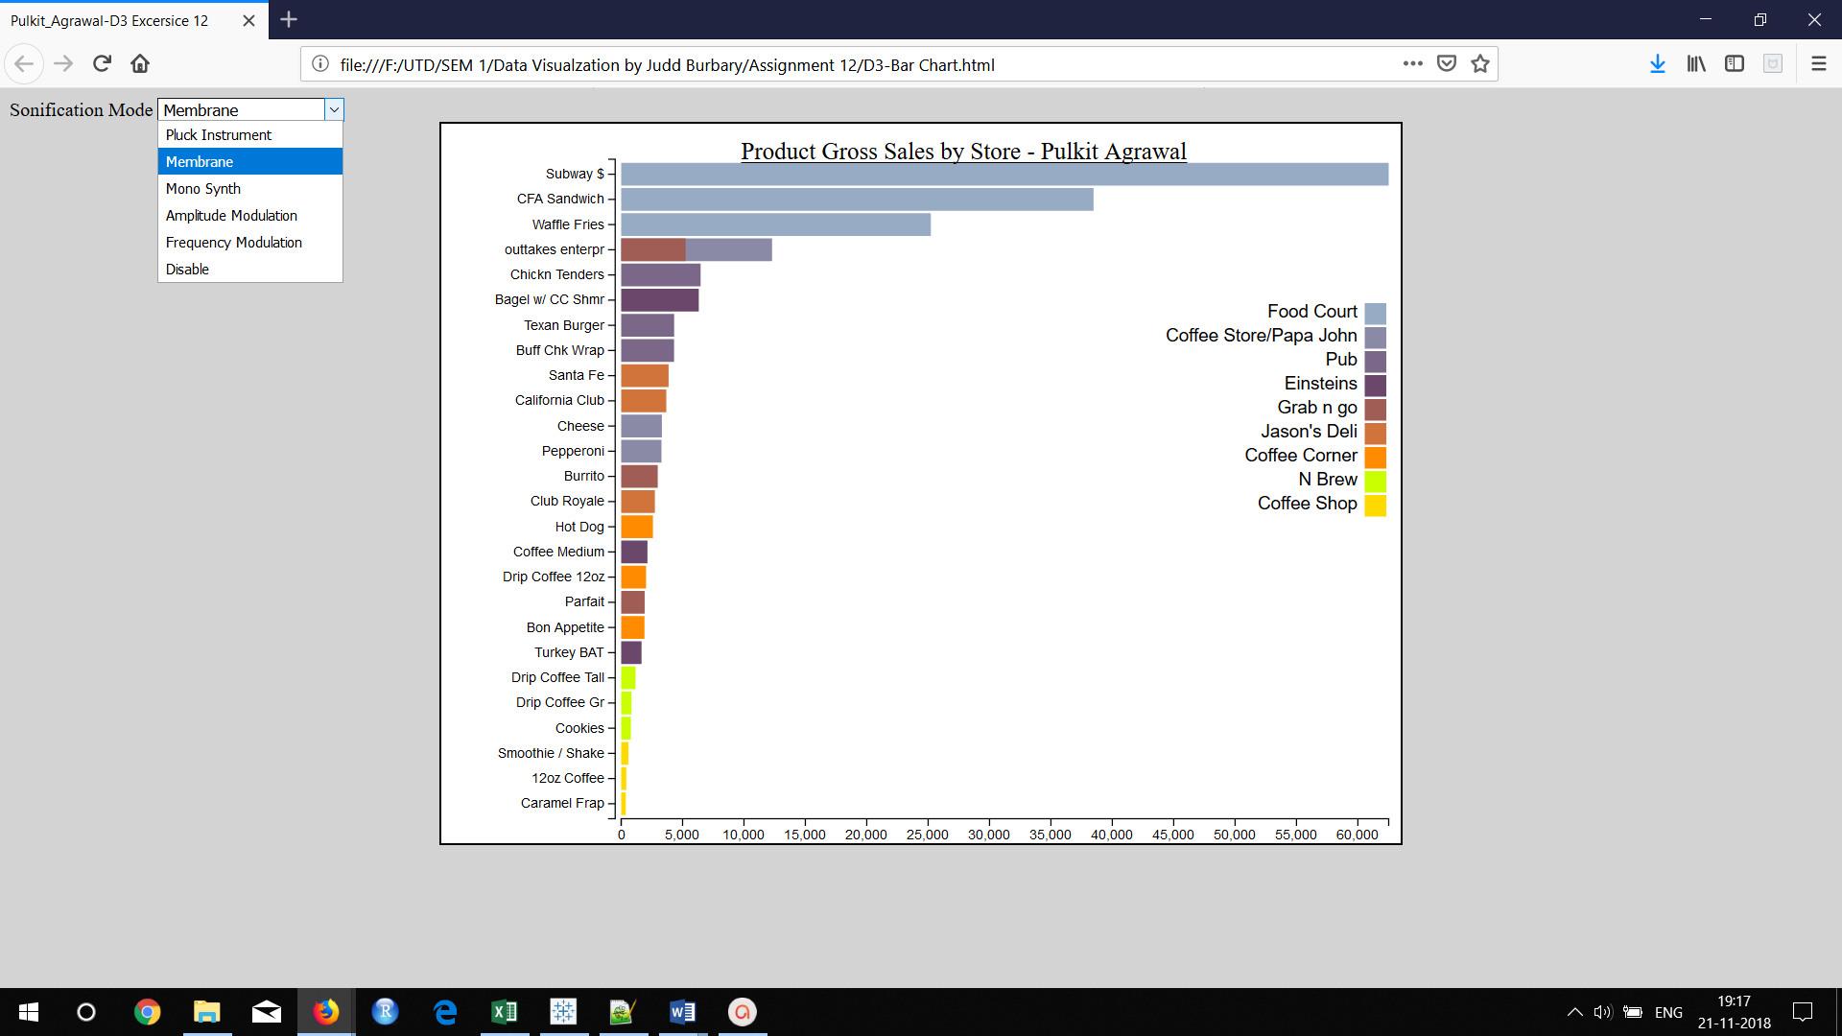

Q5. WHY DO YOU HEAR DIFFERENT FREQUENCY SOUNDS HERE?

Answer: The frequency of the sound is different because the price of each product is different. We have used different variables related to the price of the product and frequency in the code which results in different frequencies for different products.

Q7. VIDEO SUBMISSION